**IoT-Enabled Risk Monitoring System**

**INTRODUCTION**

Growing demand for perishable products across the globe is a great challenge to cold chain logistics. The proposed application focuses on cold supply chain management.

The IoT enabled risk monitoring system provides a solution that utilises IoT-enabled sensors to continuously monitor and manage the environment of temperature-sensitive packages to prevent spoilage and waste as they move through the chain, humidity and other gas compositions like CO2 etc. The proposed system uses GPS technology to track precise locations of the cold storage. Without proper monitoring, suboptimal conditions during transport and storage can damage the quality of these products. By utilising precise temperature sensors, humidity sensors and other gas detecting sensors cold chain management solutions can alert the drivers of potential issues with a shipment immediately if they’re on the road or parked for the night, allowing for a swift response before the situation becomes critical or any inventory is lost. It improves predictive maintenance, compliance, remote monitoring, fleet management, and predictive quality and usage analysis by integrating sensor data with supply chain management, regulatory reporting and other platforms.The proposed system collects data from the different sensors and GPS coordinates. It will be sent to the cloud and stored in the cloud database for viewing the history data and generating aggregated reports.

The system will also predict the future results based on the previously acquired data and this will also be notified prior to the user. The user will be able to monitor the exact temperature and other parameters.

**APPROACH**

The objective of our prototype is to monitor temperature, humidity, different gas compositions and other required parameters in large commercial premises.It has 3 fundamental parts such as data acquisition,cloud computation and presentation layer.The Data Acquisition deals with Sensor data & GPS Data that is collected by the PLC.This data is sent to the Edge device using MODBUS protocol.This acquired data is processed by the python agent which is published to the cloud.The cloud computation stores acquired data in MongoDB & republishes it to presentation layer(history , data, reports & predictions).Here the MQTT subscriber continuously subscribes the topic in which the data is sent and then stored in DB.This live data is published through websocket to the presentation layer.The Presentation Layer displays live data (history, data, reports & predictions)*

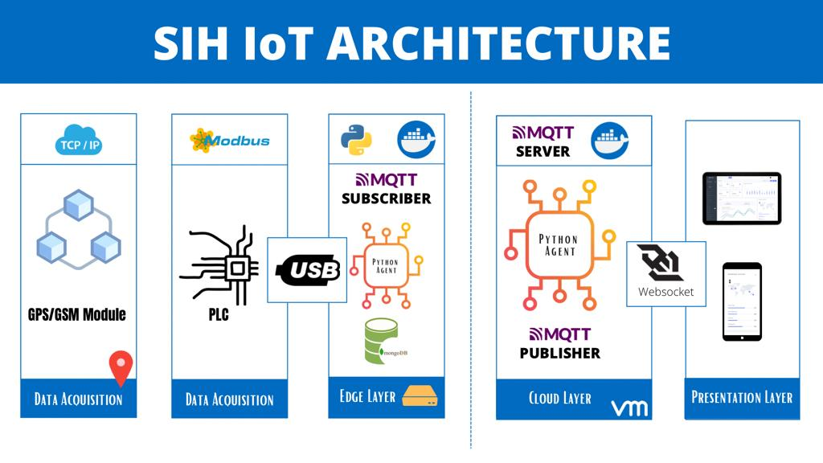

**FINDINGS**

The live monitoring ensures that the products are handled within the desired conditions, namely temperature, humidity and real time location so that any violation of the handling requirements is visible among all cold chain parties. In addition, for cold warehouses and rooms in different cold chain facilities, the personal occupational safety risk assessment is established by considering the surrounding environment and the operators’ personal health status. The frequency of occupational safety risks occurring, including cold-related accidents and injuries, can be greatly reduced. In addition, worker satisfaction and operational efficiency are improved. Therefore, it provides a solid foundation for assessing and identifying product quality and occupational safety risks in cold chain activities.

**TECHNOLOGY STACK USED**

| * Python3 * Django * Framework * MongoDB | * Modbus RTU * Docker * Android * Retrofit 2 | * Google maps * MQTT |
| --- | --- | --- |

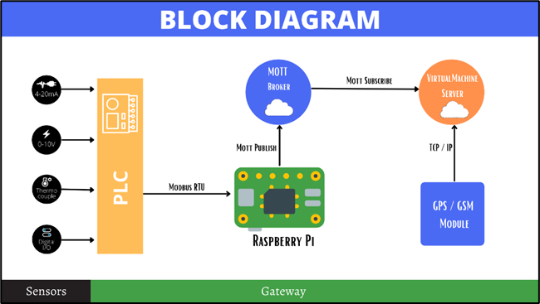

**HARDWARE SETUP**

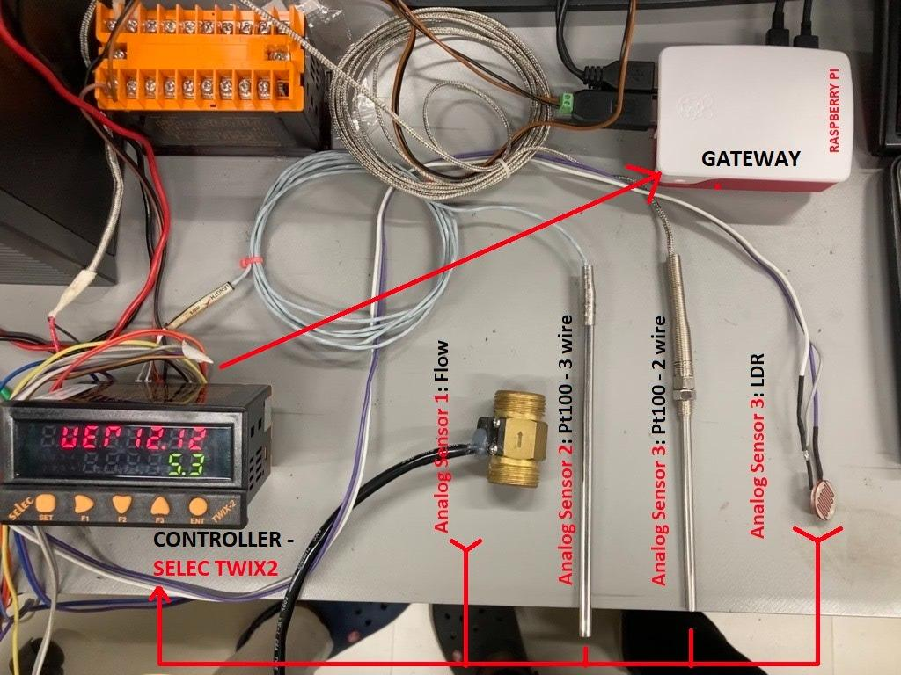

**REFERENCE UI**

